ER Diagram

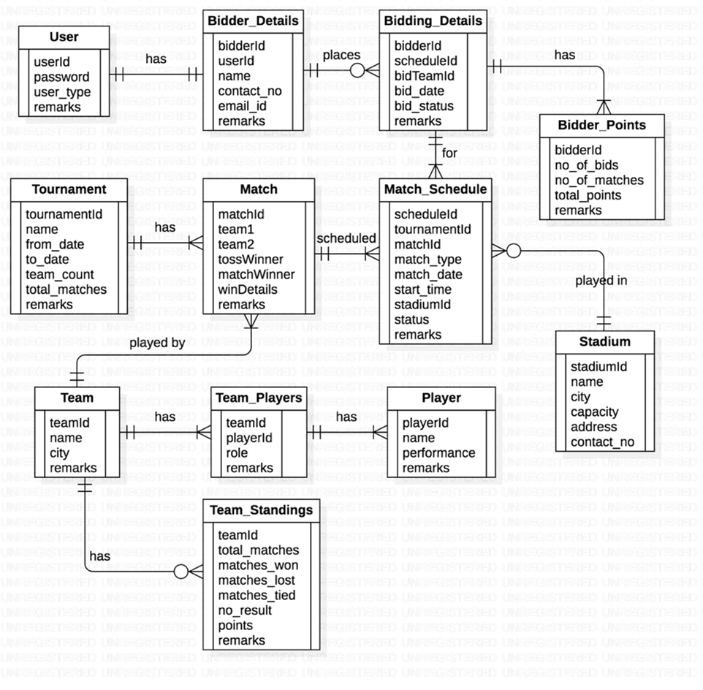

Instructions:

1. Create these tables in the database by running the database script provided

2. The script also has statements to insert appropriate data into all these tables

3. Test the successful execution of the script by selecting some rows from few tables

4. Clearly understand the structure of each table and relationships among them

5. Insert / update appropriate rows into relevant tables if you need to get more rows in the output to verify your answers

Questions – Write SQL queries to get data for following requirements:

1. Show the percentage of wins of each bidder in the order of highest to lowest percentage.

2. Which teams have got the highest and the lowest no. of bids?

3. In a given stadium, what is the percentage of wins by a team which has won the toss?

4. What is the total no. of bids placed on the team that has won the highest no. of matches?

5. From the current team standings, if a bidder places a bid on which of the teams, there is a possibility of (s)he winning the highest no. of points – in simple words, identify the team which has the highest jump in its total points (in terms of percentage) from the previous year to current year.

**DATASET -** <https://drive.google.com/file/d/1Sn3JjpYJz27xhuoirfjGXKFRZOxZ3860/view?usp=drive_link>